|  |  |  |
| --- | --- | --- |
| Date | | 09.11.2022 |
| Team Id | | PNT2022TMID48656 |
| Project Name | | Iot based safety gadget for child safety monitoring and notification |
| Maximum marks |  | |

**AIM:**

To create IBM Watson iot platform.

**STEP1:**

Enter your ibm login credentials.

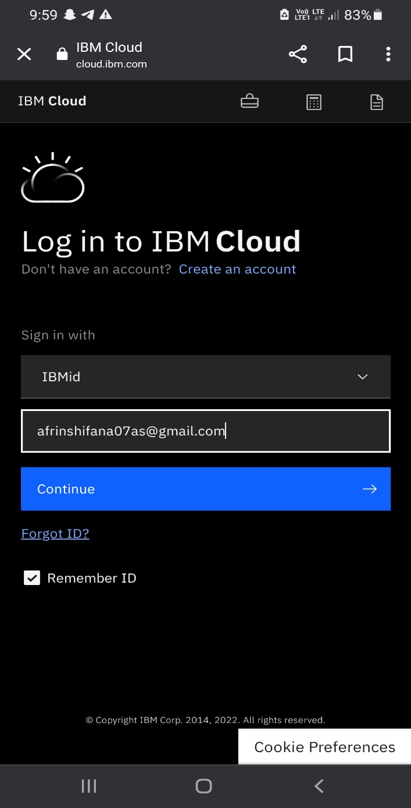

**STEP2:**

Click on the create button.

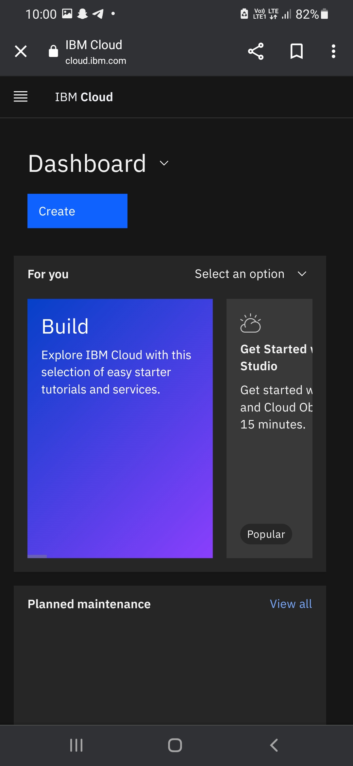

**STEP3:**

Search for internet of things platform in the search bar.

**STEP3:**

Search for internet of things platform on the search bar.

